**Batch: B-1 Experiment Number: 1 - Networking Commands**

**Roll Number: 16010422234 Name: Chandana Ramesh Galgali**

**Aim of the Experiment: Study of various networking commands.**

**Program/ Steps:**

**1. Type each networking command in the command prompt and paste snapshots of the output.**

**Output/Result:**

**1. ping**

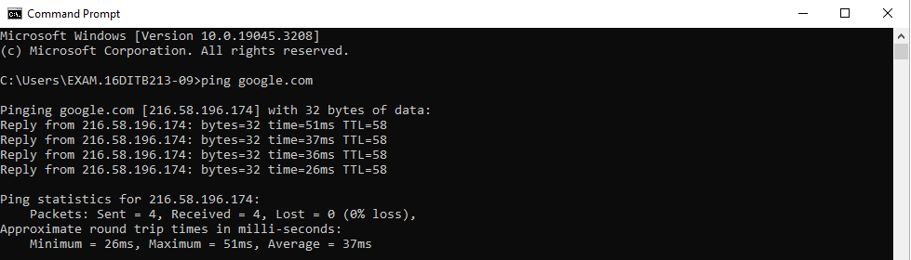

**2. ipconfig**

**Used without parameters:**

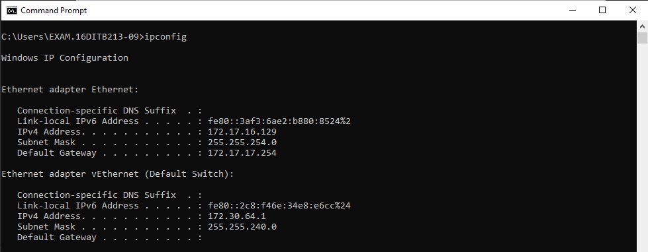

**ipconfig/all:**

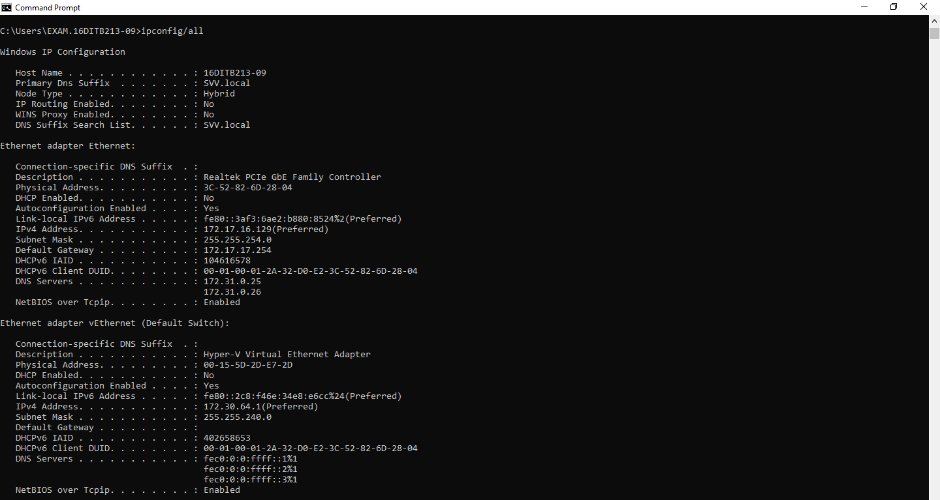

**ipconfig/renew:**

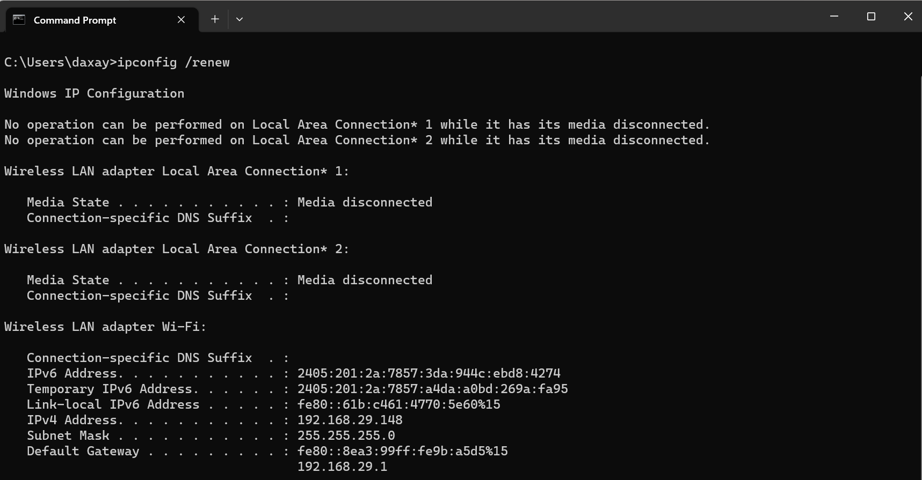

**ipconfig/renew:**

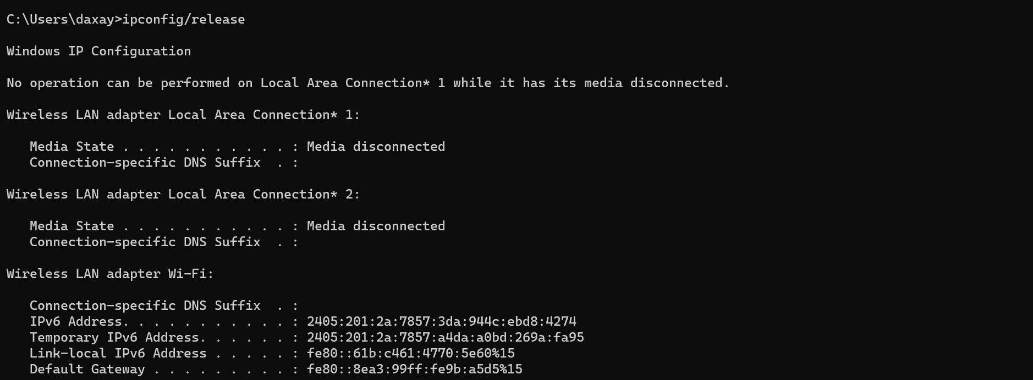

**ipconfig/flushdns:**



**3. tracert**

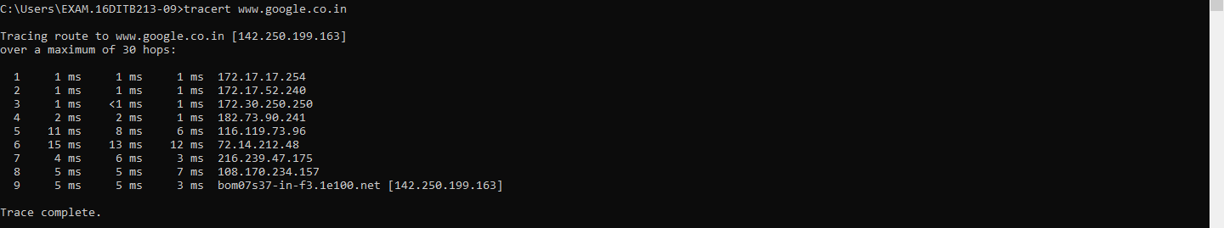

**tracert-d**

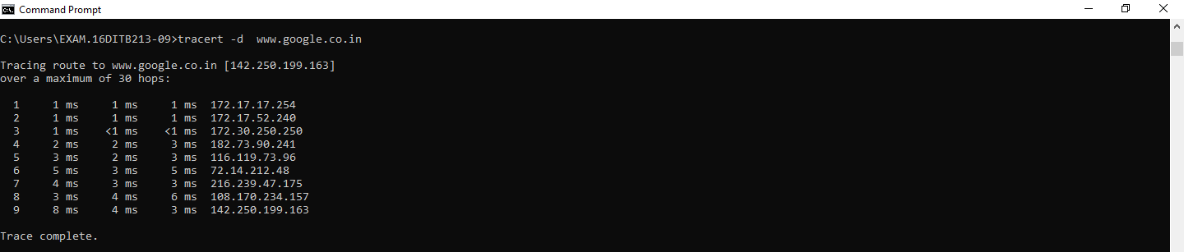

**4. Arp**

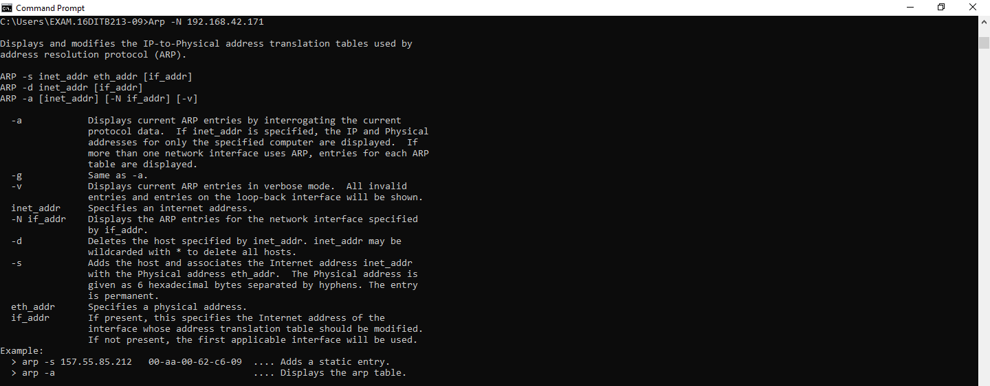

**5. Netstat**

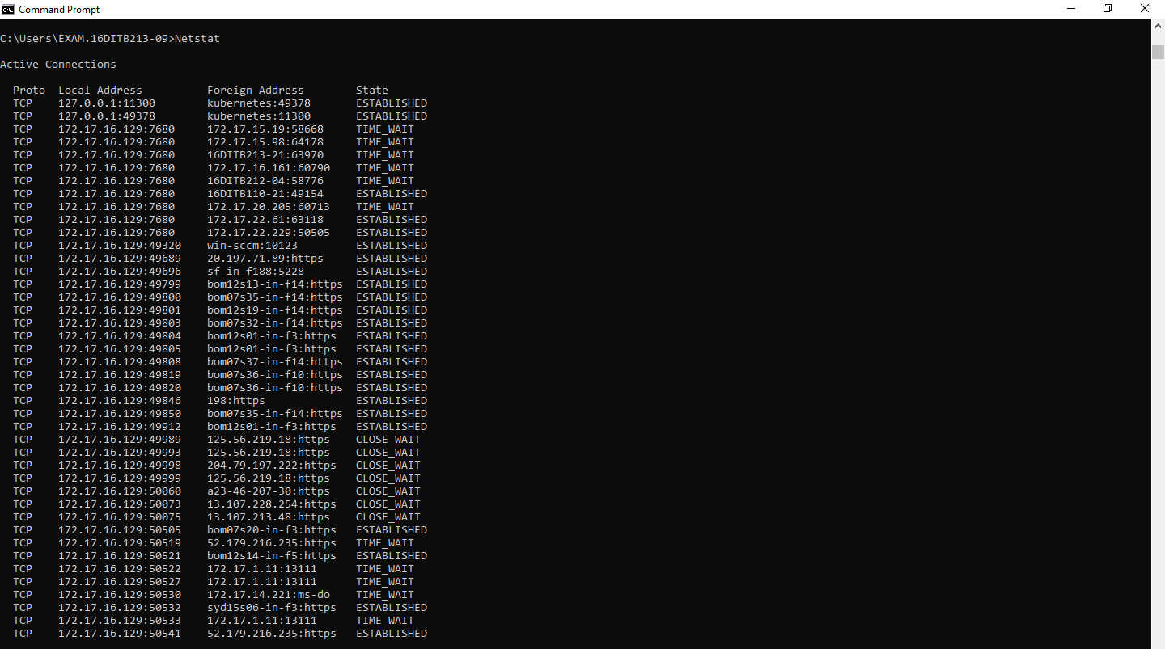

**Netstat -a**

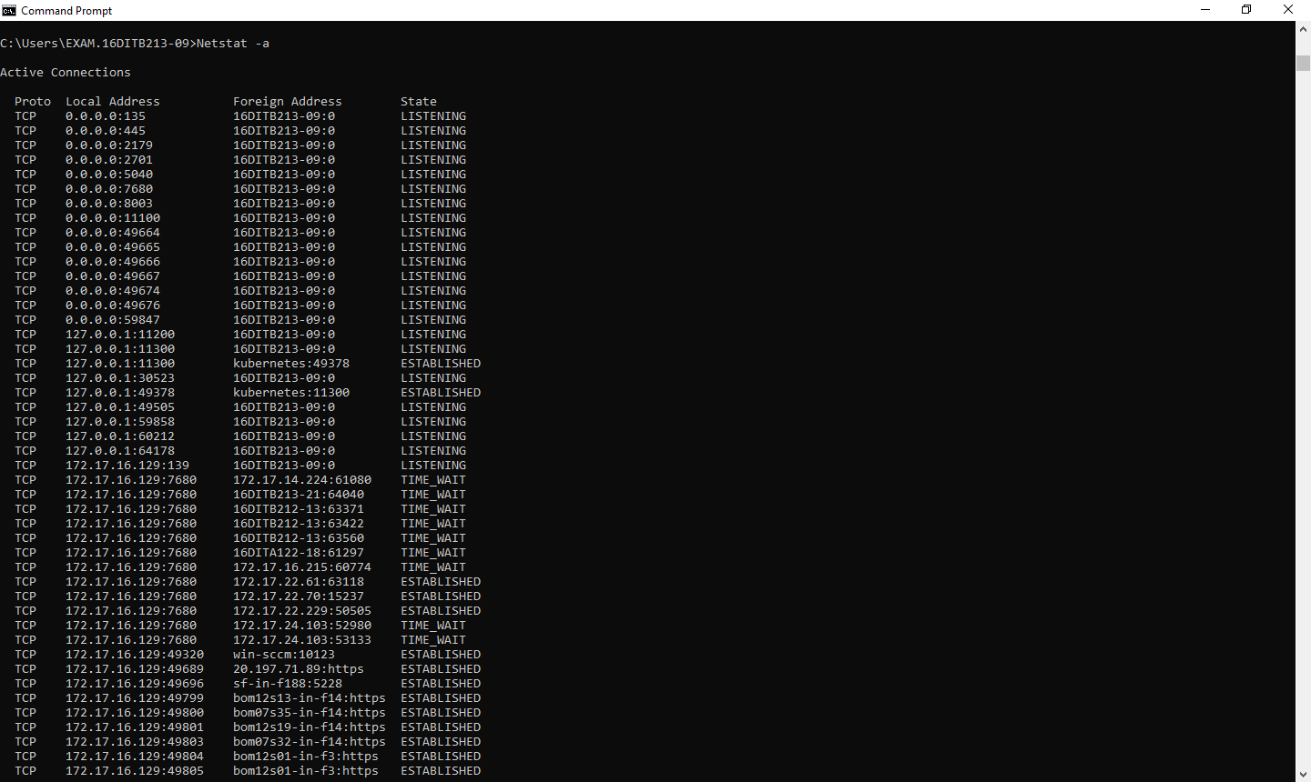

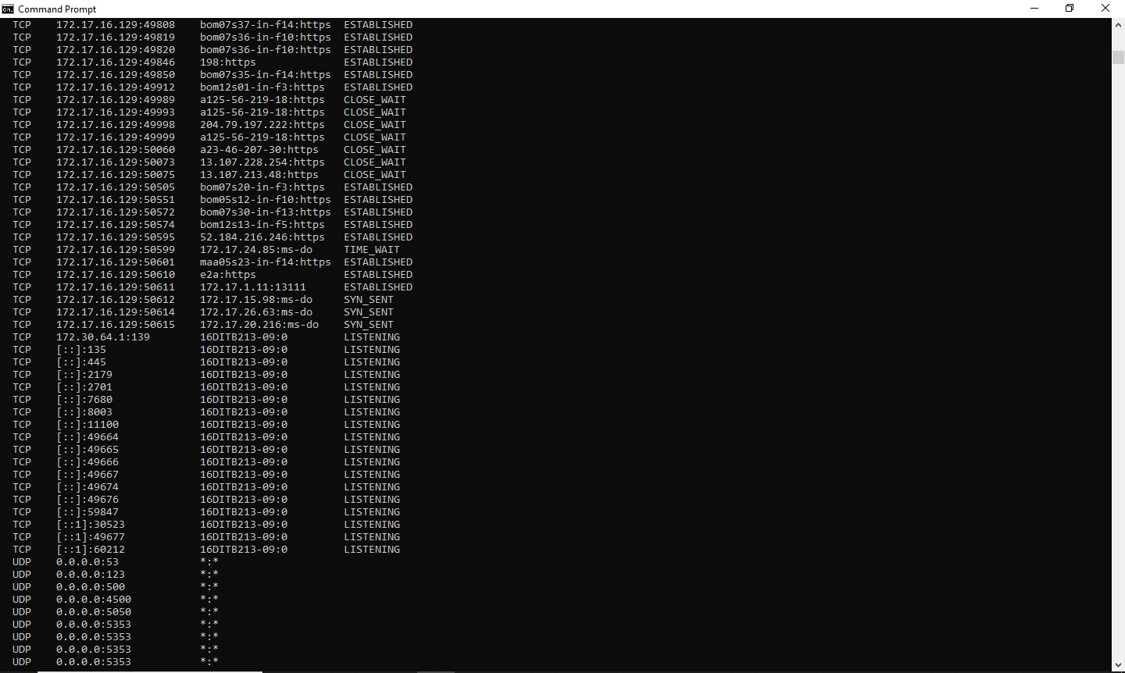

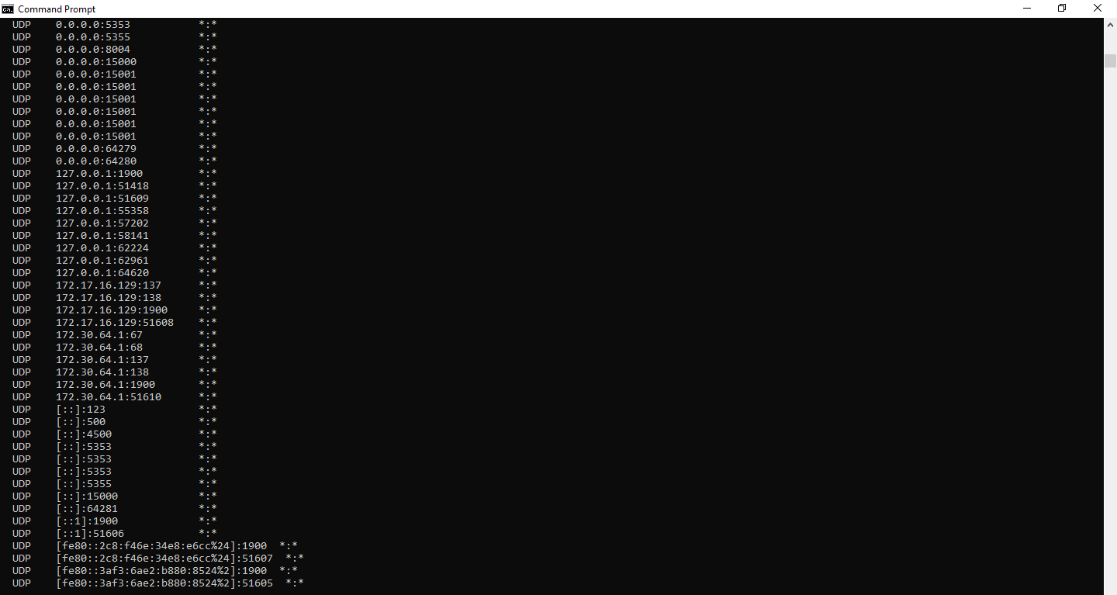

**Netstat -e**

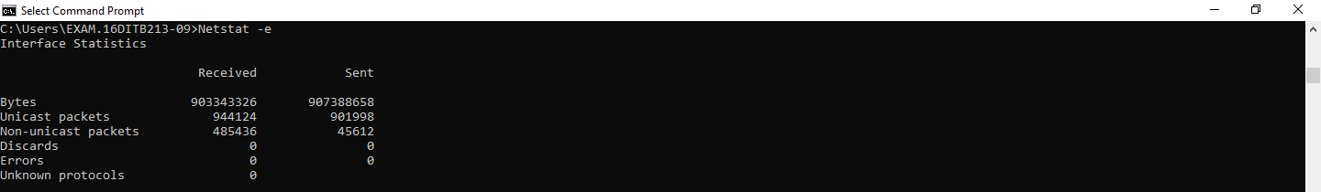

**Netstat -n**

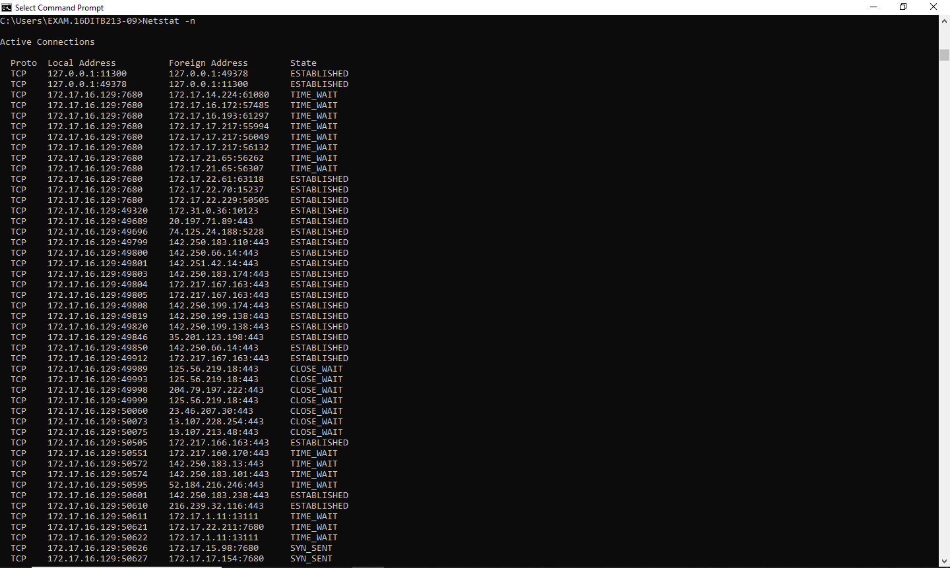



**Netstat -o**

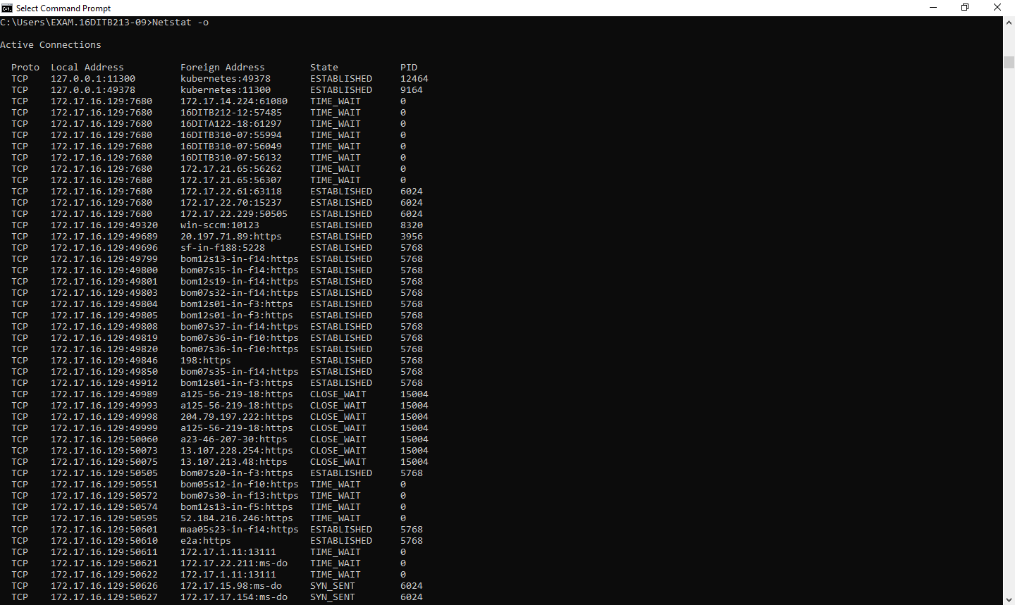

**Netstat -p**



**Netstat -s**

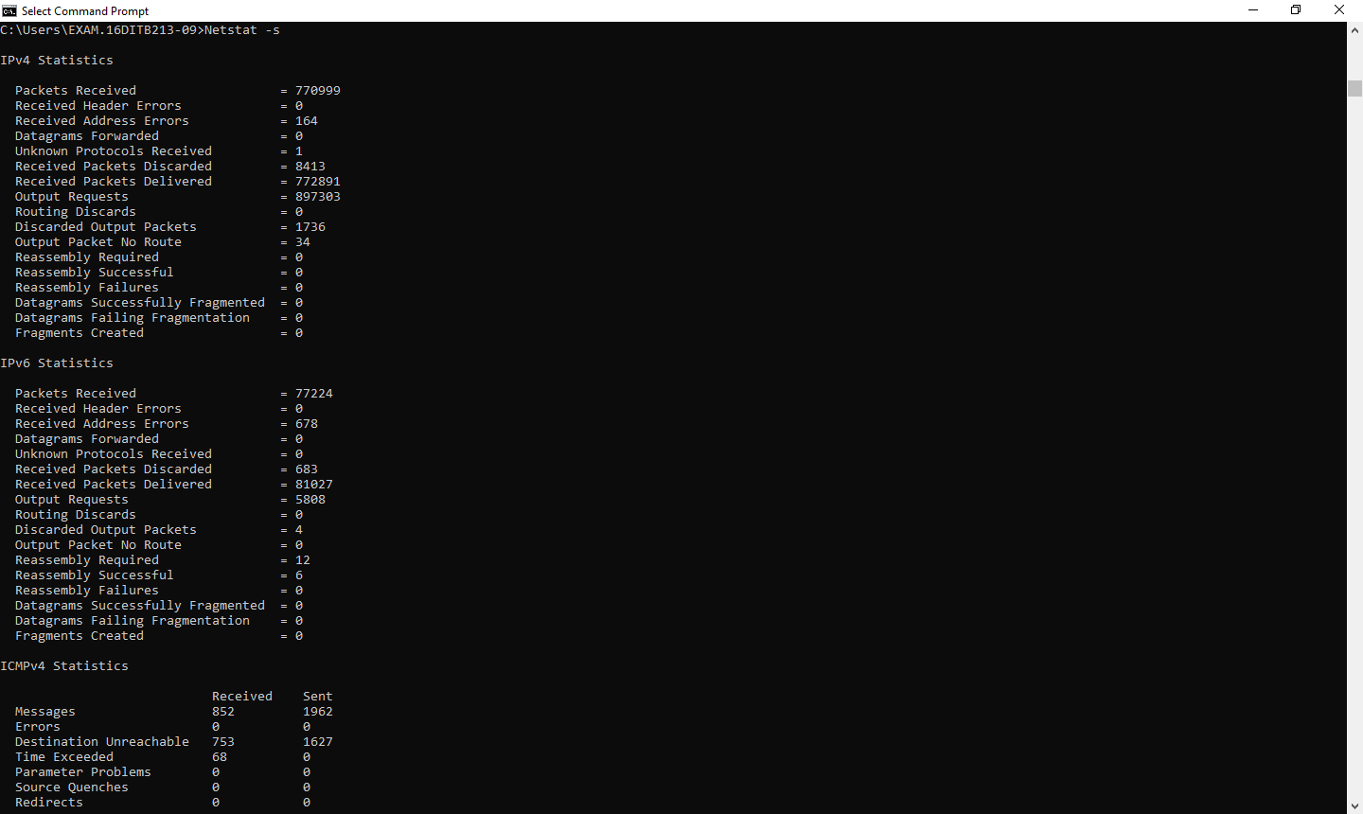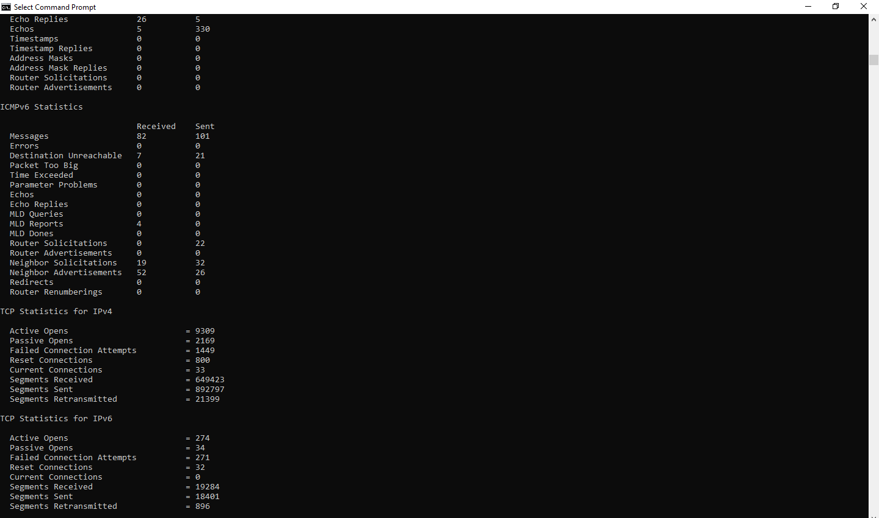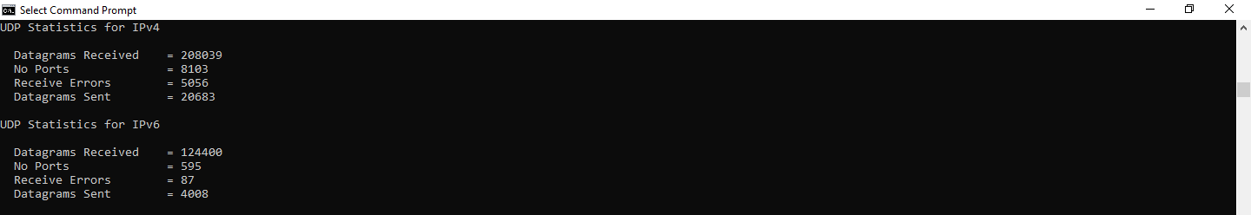

**Netstat -r**

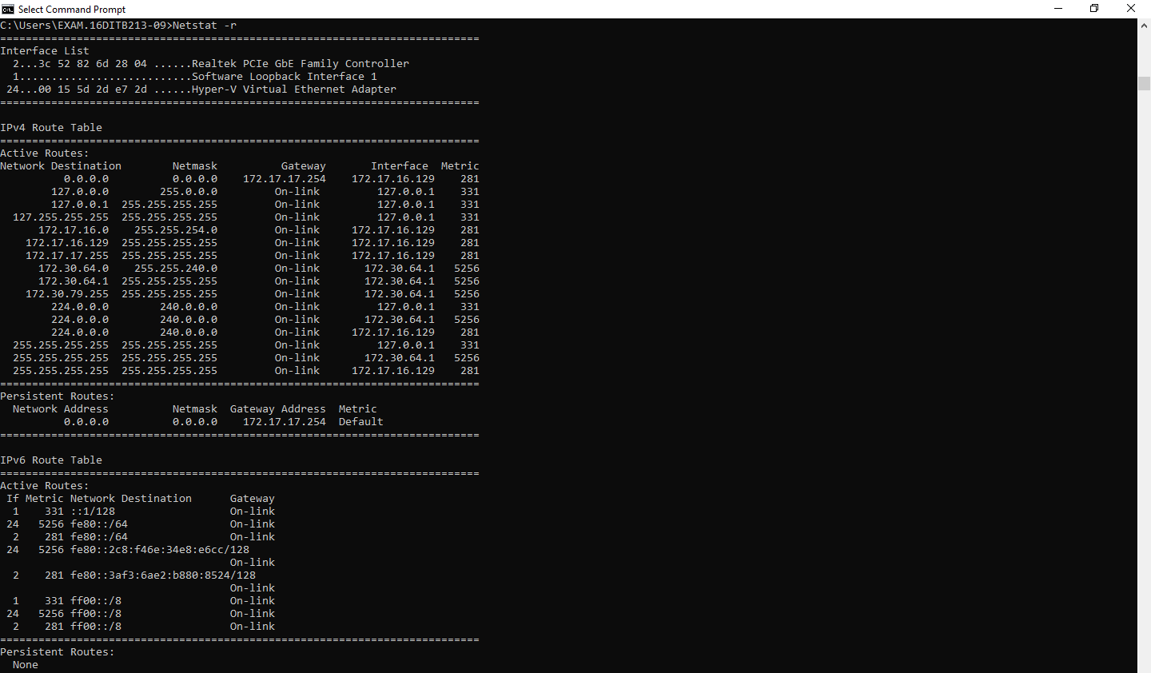

**Post Lab Question-Answers:**

1. ICMP is used in _________

**a) Ping**

b) Traceroute

c) Ifconfig

d) Both Ping & Traceroute

2. __________ command is used to manipulate TCP/IP routing table.

**a) route**

b) Ipconfig

c) Ifconfig

d) Traceroute

3. Select the false statement from the following.

a) Nslookup is used to query a DNS server for DNS data

b) Ping is used to check connectivity

c) Pathping combines the functionality of ping with that of route

**d) Ifconfig can configure TCP/IP network interface parameters**

**Outcomes: Understand the data communication system, network topologies and network devices.**

**Conclusion (based on the Results and outcomes achieved):**

The experiment highlights the importance of these networking commands in troubleshooting and managing network connections. They provide valuable insights into DNS resolution, network connectivity, and network path analysis, enabling network administrators and users to diagnose and resolve network-related issues effectively.

**References:**

**Books/ Journals/ Websites:**

1. Behrouz A Forouzan, Data Communication and Networking, Tata Mc Graw hill, India, 4th Edition
2. A. S. Tanenbaum, ”Computer Networks”, 4th edition, Prentice Hall
3. Behrouz A Forouzan, Data Communication and Networking, Tata Mc Graw hill, India, 4th Edition
4. A. S. Tanenbaum, ”Computer Networks”, 4th edition, Prentice Hall